**10. ReactJS-HOL**

**Implementation:**

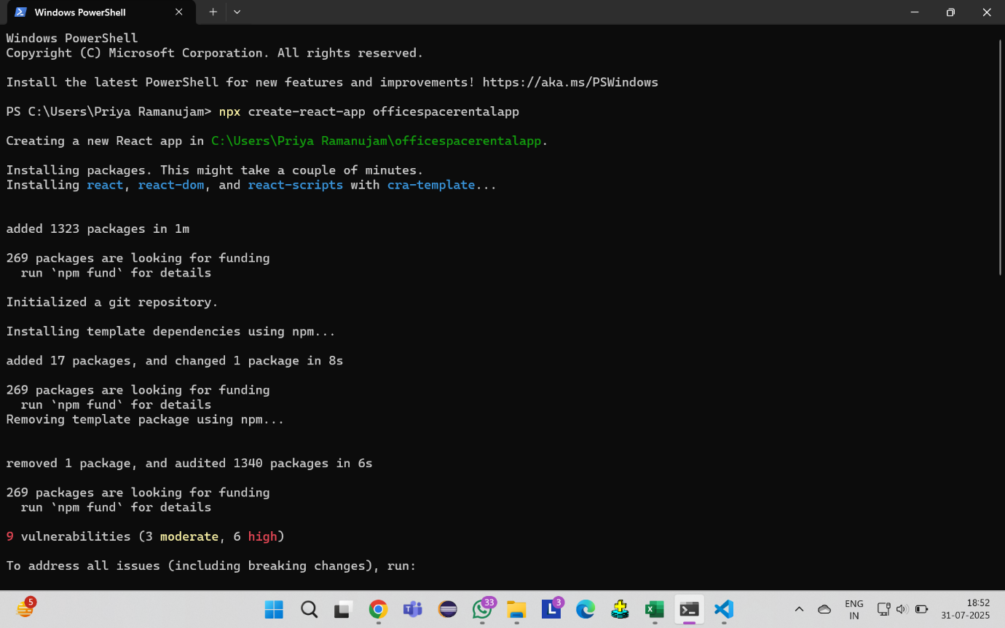

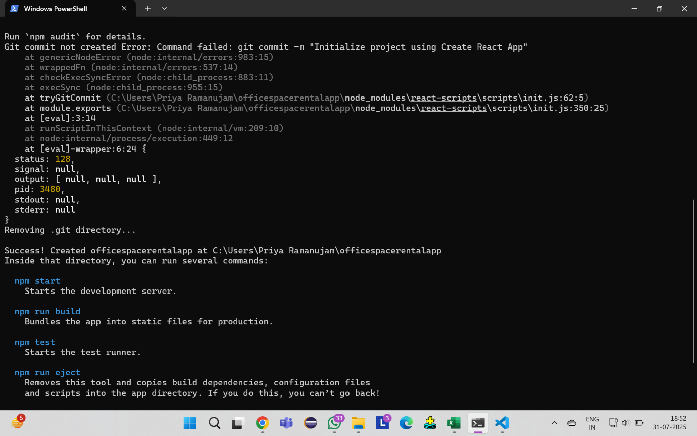

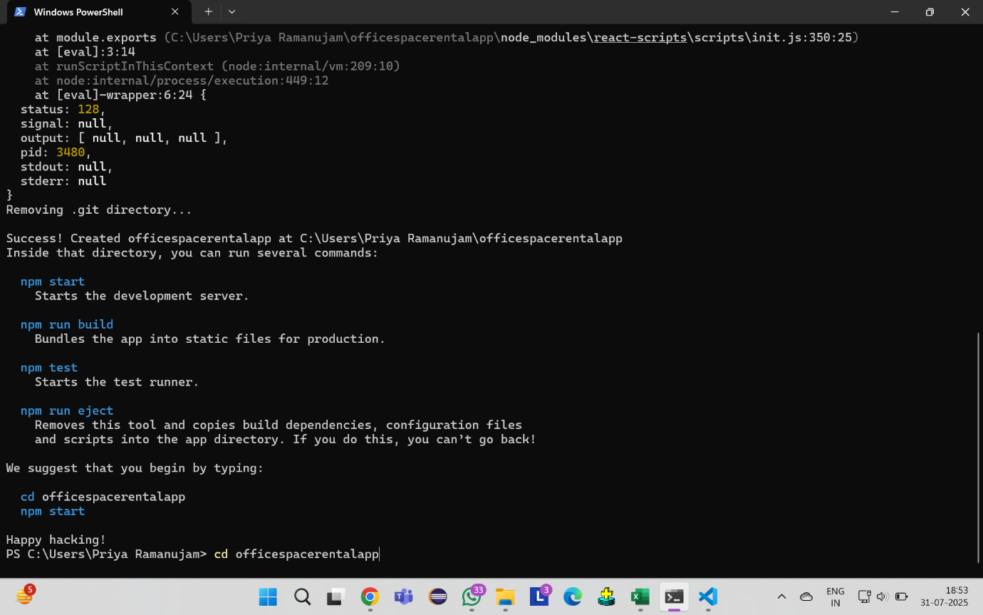

**App.js**

import React from 'react';

import './App.css';

function App() {

  const officeSpaces = [

    {

      id: 1,

      name: "Premium Office Suite",

      rent: 75000,

      address: "123 Business District, Downtown",

      image: "https://images.unsplash.com/photo-1497366216548-37526070297c?w=400&h=250&fit=crop"

    },

    {

      id: 2,

      name: "Modern Co-working Space",

      rent: 45000,

      address: "456 Tech Hub, Innovation Center",

      image: "https://images.unsplash.com/photo-1497366811353-6870744d04b2?w=400&h=250&fit=crop"

    },

    {

      id: 3,

      name: "Executive Office",

      rent: 85000,

      address: "789 Corporate Plaza, Business Bay",

      image: "https://images.unsplash.com/photo-1497366754035-f200968a6e72?w=400&h=250&fit=crop"

    },

    {

      id: 4,

      name: "Startup Office Space",

      rent: 35000,

      address: "321 Entrepreneur Street, Startup Valley",

      image: "https://images.unsplash.com/photo-1524758631624-e2822e304c36?w=400&h=250&fit=crop"

    }

  ];

  const getRentColor = (rent) => {

    return rent < 60000 ? 'red' : 'green';

  };

  return (

    <div className="App">

      <header className="app-header">

        <h1>Office Space Rental</h1>

        <p>Find your perfect workspace</p>

      </header>

      <div className="office-container">

        {officeSpaces.map((office) => (

          <div key={office.id} className="office-card">

            <img

              src={office.image}

              alt={office.name}

              className="office-image"

            />

            <div className="office-details">

              <h3 className="office-name">{office.name}</h3>

                <p className="office-rent">

                Rent: ₹

                <span style={{ color: getRentColor(office.rent), fontWeight: 'bold' }}>

                  {office.rent.toLocaleString()}

                </span>

                /month

              </p>

              <p className="office-address">

                <strong>Address:</strong> {office.address}

              </p>

            </div>

          </div>

        ))}

      </div>

    </div>

  );

}

export default App;

**App.css**

* {

  margin: 0;

  padding: 0;

  box-sizing: border-box;

}

body {

  font-family: 'Segoe UI', Tahoma, Geneva, Verdana, sans-serif;

  background-color: #f5f5f5;

  line-height: 1.6;

}

.App {

  max-width: 1200px;

  margin: 0 auto;

  padding: 20px;

  min-height: 100vh;

  display: flex;

  flex-direction: column;

}

.app-header {

  text-align: center;

  margin-bottom: 40px;

  padding: 30px 0;

  background: linear-gradient(135deg, #667eea 0%, #764ba2 100%);

  color: white;

  border-radius: 15px;

  box-shadow: 0 8px 32px rgba(0, 0, 0, 0.1);

}

.app-header h1 {

  font-size: 3rem;

  margin-bottom: 10px;

  text-shadow: 2px 2px 4px rgba(0, 0, 0, 0.3);

}

.app-header p {

  font-size: 1.2rem;

  opacity: 0.9;

}

.office-container {

  display: grid;

  grid-template-columns: repeat(auto-fit, minmax(350px, 1fr));

  gap: 30px;

  margin-bottom: 40px;

  flex: 1;

}

.office-card {

  background: white;

  border-radius: 15px;

  box-shadow: 0 10px 30px rgba(0, 0, 0, 0.1);

  overflow: hidden;

  transition: all 0.3s ease;

  border: 1px solid #e0e0e0;

}

.office-card:hover {

  transform: translateY(-10px);

  box-shadow: 0 20px 40px rgba(0, 0, 0, 0.15);

}

.image-container {

  position: relative;

  overflow: hidden;

  height: 250px;

}

.office-image {

  width: 100%;

  height: 100%;

  object-fit: cover;

  transition: transform 0.3s ease;

}

.office-card:hover .office-image {

  transform: scale(1.05);

}

.office-details {

  padding: 25px;

}

.office-name {

  font-size: 1.5rem;

  color: #333;

  margin-bottom: 15px;

  font-weight: 600;

}

.office-rent {

  font-size: 1.2rem;

  margin-bottom: 15px;

  color: #555;

}

.office-address {

  color: #666;

  margin-bottom: 20px;

  font-size: 1rem;

  line-height: 1.5;

}

.office-address strong {

  color: #333;

}

.rent-status {

  display: flex;

  justify-content: flex-end;

}

.status-badge {

  padding: 8px 16px;

  border-radius: 20px;

  font-size: 0.9rem;

  font-weight: 600;

  text-transform: uppercase;

  letter-spacing: 0.5px;

}

.status-badge.affordable {

  background-color: #ffebee;

  color: #c62828;

  border: 2px solid #ffcdd2;

}

.status-badge.premium {

  background-color: #e8f5e8;

  color: #2e7d32;

  border: 2px solid #c8e6c9;

}

.app-footer {

  text-align: center;

  padding: 20px 0;

  margin-top: 40px;

  color: #666;

  border-top: 1px solid #e0e0e0;

}

@media (max-width: 768px) {

  .App {

    padding: 10px;

  }

  .app-header h1 {

    font-size: 2rem;

  }

  .office-container {

    grid-template-columns: 1fr;

    gap: 20px;

  }

  .office-card {

    margin: 0 10px;

  }

  .office-details {

    padding: 20px;

  }

  .office-name {

    font-size: 1.3rem;

  }

}

@media (max-width: 480px) {

  .app-header {

    padding: 20px 0;

    margin: 0 -10px 30px -10px;

  }

  .app-header h1 {

    font-size: 1.8rem;

  }

  .app-header p {

    font-size: 1rem;

  }

  .office-card {

    margin: 0;

  }

}

**OUTPUT:**

